## PROGRAM DEFINITION

|  |
| --- |
|  |
| * Program untuk cetak laporan deposit |

## RELATED TABLES

|  |  |
| --- | --- |
|  | **Access** |
| * PMT_AGREEMENT_DEPOSIT | * RW |

## ROLES

|  |  |
| --- | --- |
|  | **Test** |
| * User yg mempunyai akses ke program |  |

## MAIN FORM

### USER INTERFACE

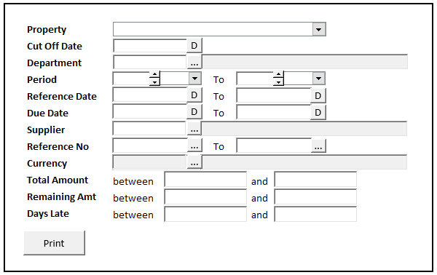h\g

#### INITIAL VERSION

|  |  |
| --- | --- |
|  | **Test** |
| * Set VAR_COMPANY_ID = Login User’s Company ID * Set VAR_USER_ID = Login User ID * Set VAR_LANGUAGE_ID = Login User’s Language ID * Get Property List to Combobox Property [PROPERTY_LIST]:   EXEC RSP_GS_GET_PROPERTY_LIST ‘VAR_CCOMPANY_ID’, ‘VAR_LANGUAGE_ID’  Set Value : CPROPERTY_ID Set Display : CPROPERTY_NAME  As Parameter: CPROPERTY_ID   * Jalankan RSP_GS_GET_PERIOD_YEAR_RANGE dengan parameter, simpan hasil ke VAR_GSM_PERIOD   + VAR_COMPANY_ID   + ‘’ (Empty String)   + ‘’ (Empty String) * Jalankan RSP_CB_GET_SYSTEM_PARAM dengan parameter, simpan hasil ke VAR_CB_SYSTEM_PARAM   + VAR_COMPANY_ID   + VAR_LANGUAGE_ID   ‘TAMBAHAN KEPERLUAN LOOKUP’   * Jalankan RSP_GS_GET_TRANS_CODE_INFO dengan parameter, simpan hasil ke VAR_TRANSACTION_CODE_INIT   + VAR_COMPANY_ID   + ‘110010’   SET VAR_CTRANSACTION_NAME = VAR_TRANSACTION_CODE_INIT.CTRANSACTION_NAME |  |

### BUTTON DEFINITION

|  |  |
| --- | --- |
| **Button Name** | **Action** |
| Print | Jalankan PRINT REPORT PROCESS |
|  |  |

### DISPLAY PROCESS

#### FIELD DEFINITION

|  |  |  |  |
| --- | --- | --- | --- |
| **Name** | **Field** | **Type** | **Validation** |
| Property | Set Value : CPROPERTY_ID  Set Display : CPROPERTY_NAME  As Parameter: CPROPERTY_ID | Combobox | * Mandatory * Get DataSource from [PROPERTY_LIST] * IF Combobox Empty   + Display message “Please select property !” |
| Cut Off Date | CCUT_OFF_DATE | Datetime picker | * Default Value = Date.Today * Set Value CCUT_OFF_DATE = DATE FORMAT CHAR(8) |
| Department | * CDEPT_CODE * CDEPT_NAME * Value : CDEPT_CODE | Textbox & Button Lookup | * Department Name always disabled * Dept Code & button lookup always enabled * Do Lookup GSL00710 DEPARTMENT PROPERTY LOOKUP, Parameter:   + VAR_COMPANY_ID   + Selected Property ID (CPROPERTY_ID)   + VAR_USER_ID * Set CDEPT_CODE = lookup.CDEPT_CODE * Set CDEPT_NAME = lookup.CDEPT_NAME |
| Period From Year | As Parameter: CFROM_YEAR | Spinner   * Minimum Value = VAR_GSM_PERIOD.IMIN_YEAR * Minimum Value = VAR_GSM_PERIOD.IMAX_YEAR * Stepping value = 1   Set Default selected value = VAR_CB_SYSTEM_PARAM.CSOFT_PERIOD_YY | * Enable on = Radio Checked : List, Activity |
| Period Month From | As Parameter: CFROM_MONTH | Combobox  Isi combobox dengan RSP_GS_GET_PERIOD_DT_LIST dengan parameter:   * VAR_COMPANY_ID * Year.Today   Set Item Code=CPERIOD_NO  Set Item Name=CPERIOD_NO | * Default Value = Month.Today * Enable on = Radio Checked : List, Activity |
| Period Year To | As Parameter: CTO_YEAR | Spinner   * Minimum Value = VAR_GSM_PERIOD.IMIN_YEAR * Minimum Value = VAR_GSM_PERIOD.IMAX_YEAR * Stepping value = 1   Set Default selected value = VAR_CB_SYSTEM_PARAM.CSOFT_PERIOD_YY | * Default Value = Year.Today * Enable on = Radio Checked : List, Activity |
| Period Month To | As Parameter: CTO_MONTH | Combobox  Isi combobox dengan RSP_GS_GET_PERIOD_DT_LIST dengan parameter:   * VAR_COMPANY_ID * Year.Today   Set Item Code=CPERIOD_NO  Set Item Name=CPERIOD_NO | * Default Value = Month.Today * Enable on = Radio Checked : List, Activity |
| From Reference Date | CFROM_REFERENCE_DATE | Datetime picker | * Default Value Today Date * To Reference Date cannot be early than From Reference Date * Set CFROM_REFERENCE_DATE = DATE FORMAT CHAR(8) |
| To Reference Date | CTO_REFERENCE_DATE | Datetime picker | * Default Value Today Date * To Reference Date cannot be early than From Reference Date * Set CFROM_REFERENCE_DATE = DATE FORMAT CHAR(8) |
| From Due Date | CFROM_DUE_DATE | Datetime picker | * Default Value Today Date * To Due Date cannot be early than From Due Date * Set CFROM_DUE_DATE = DATE FORMAT CHAR(8) |
| To Due Date | CTO_DUE_DATE | Datetime picker | * Default Value Today Date * To Due Date cannot be early than From Due Date * Set CTO_DUE_DATE = DATE FORMAT CHAR(8) |
| Supplier | CSUPPLIER_ID CSUPPLIER_NAME  Value: CSUPPLIER_ID | Textbox & Button Lookup | * Customer Name always disabled * Customer Id & button lookup always enabled * Do Lookup APL00100 SUPPLIER LOOKUP, Parameter:   + VAR_COMPANY_ID   + Selected Property ID (CPROPERTY_ID)   + VAR_LANG_ID * Set CSUPPLIER_ID = lookup.CSUPPLIER_ID * Set CSUPPLIER_NAME = lookup.CSUPPLIER_NAME |
| From Reference No | CFROM_REFERENCE_NO | Textbox & Button Lookup | * Lookup dengan program APL00500 AP TRANSACTION LOOKUP, dgn parameter:   o VAR_COMPANY_ID  o Selected PROPERTY_ID  o Selected DEPT_CODE  o Selected Supplier ID  o VAR_USER_ID  o ‘110010’  o VAR_CTRANSACTION_NAME  o 1  o 0  o VAR_LANG_ID  SET CREFERENCE_NO = lookup.CREF_NO |
| To Reference No | CTO_REFERENCE_NO | Textbox & Button Lookup | * Lookup dengan program APL00500 AP TRANSACTION LOOKUP, dgn parameter:   o VAR_COMPANY_ID  o Selected PROPERTY_ID  o Selected DEPT_CODE  o Selected Supplier ID  o VAR_USER_ID  o ‘110010’  o VAR_CTRANSACTION_NAME  o 1  o 0  o VAR_LANG_ID   * SET CREFERENCE_NO = lookup.CREF_NO |
| Currency | CCURRENCY | Textbox & Button Lookup | * Currency always disabled * Button lookup always enabled * Do Lookup GSL00300 CURRENCY LOOKUP, Parameter:   + VAR_COMPANY_ID   + VAR_USER_ID * Set CCURRENCY = lookup.CCURRENCY_CODE |
| Total Amount From | NFROM_TOTAL_AMOUNT | Spinner | * Decimal places 2 |
| Total Amount To | NTO_TOTAL_AMOUNT | Spinner | * Decimal places 2 |
| Remaining Amount From | NFROM_REMAINING_AMOUNT | Spinner | * Decimal places 2 |
| Remaining Amount To | NTO_REMAINING_AMOUNT | Spinner | * Decimal places 2 |
| Days Late From | IFROM_DAYS_LATE | Spinner | * Decimal places 0 |
| Days Late To | ITO_DAYS_LATE | Spinner | * Decimal places 0 |
| Invoice Type | Set Value : CINVOICE_TYPE_CODE  Set Display : CINVOICE_TYPE_NAME  As Parameter: CINVOICE_TYPE_CODE | Combobox | * Get Datasource From:   select CCODE, CDESCRIPTION from RFT_GET_GSB_CODE_INFO ('BIMASAKTI', VAR_COMPANY_ID, '_BS_INVOICE_TYPE','', VAR_LANG_ID)   * Set CINVOICE_TYPE_CODE = CCODE * Set CINVOICE_TYPE_NAME = CDESCRIPTION |
| Invoice Group | Set Value : CINVOICE_GROUP_CODE  Set Display : CINVOICE_GROUP_NAME  As Parameter: CINVOICE_GROUP_CODE | Combobox | * Get Datasource From:   exec RSP_PM_GET_INVOICE_GROUP_LIST VAR_COMPANY_ID,Selected Property Id, VAR_USER_ID   * Set CINVOICE_GROUP_CODE = CINVGRP_CODE * Set CINVOICE_GROUP_NAME = CINVGRP_NAME |

### PRINT REPORT PROCESS

#### REPORT LAYOUT

PAPER SIZE: A4 LANDSCAPE

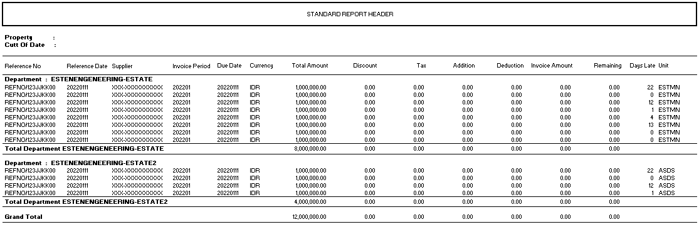

###### REPORT DEFINITION

|  |  |  |  |
| --- | --- | --- | --- |
| **Report** | **Name** | **Field** | **Validation** |
| **HEADER** | Property | Selected Property |  |
| Cut Off Date | Selected Cut Off Date |  |
|  |  |  |
| **REPORT GROUP** | Department | CDEPARTMENT_CODE |  |
|  |  |  |
| **Detail** | Reference No | CREFERENCE_NO |  |
| Reference Date | CREFERENCE_DATE |  |
| Supplier | CSUPPLIER_ID – CSUPPLIER_NAME |  |
| Invoice Period | CINVOICE_PERIOD |  |
| Due Date | CDUE_DATE |  |
| Currency | CCURRENCY |  |
| Total Amount | NTOTAL_AMOUNT |  |
| Discount | NDISCOUNT |  |
| Tax | NTAX |  |
| Addition | NADDITION |  |
| Deduction | NDEDUCTION |  |
| Invoice Amount | NINVOICE_AMOUNT |  |
| Remaining | NREMAINING |  |
| Days Late | IDAYS_LATE |  |
| Unit | CUNIT |  |
|  |  |  |
| GROUP FOOTER | Total Department | SUM(Total Amount) | Total on each Group |
|  | SUM(Discount) | Total on each Group |
|  | SUM(Tax) | Total on each Group |
|  | SUM(Addition) | Total on each Group |
|  | SUM(Deduction) | Total on each Group |
|  | SUM(Invoice Amount) | Total on each Group |
|  | SUM(Remaining) | Total on each Group |
| REPORT FOOTER | Total Department | SUM(Total Amount) | Total all Group |
|  | SUM(Discount) | Total all Group |
| Tax | SUM(Tax) | Total all Group |
| Addition | SUM(Addition) | Total all Group |
| Deduction | SUM(Deduction) | Total all Group |
| Invoice Amount | SUM(Invoice Amount) | Total all Group |
| Remaining | SUM(Remaining) | Total all Group |

###### VALIDATION

|  |  |  |
| --- | --- | --- |
| **Field** | **Condition** | **Validation Message** |
| Property | Empty | Please select Property ! |
| Cut Off Date | Empty | Please select Period Cut Off Date ! |
|  |  |  |
|  |  |  |
|  |  |  |
|  |  |  |
|  |  |  |

#### ACTION

|  |
| --- |
|  |

|  |
| --- |
| * Jalankan RSP_APR00500_GET_REPORT dengan parameter untuk Main Report   + - VAR_COMPANY_ID     - Selected CPROPERTY_ID     - Selected CCUT_OFF_DATE     - Selected CDEPT_CODE     - Selected CFROM_YEAR + Selected CFROM_MONTH (yyyymm)     - Selected CTO_YEAR + Selected CTO_MONTH (yyyymm)     - Selected CFROM_REFERENCE_DATE     - Selected CTO_REFERENCE_DATE     - Selected CFROM_DUE_DATE     - Selected CTO_DUE_DATE     - Selected CSUPPLIER_ID     - Selected CFROM_REFERENCE_NO     - Selected CTO_REFERENCE_NO     - Selected CCURRENCY     - Selected NFROM_TOTAL_AMOUNT     - Selected NTO_TOTAL_AMOUNT     - Selected NFROM_REMAINING_AMOUNT     - Selected NTO_REMAINING_AMOUNT     - Selected IFROM_DAYS_LATE     - Selected ITO_DAYS_LATE     - VAR_LANG_ID |

|  |  |  |
| --- | --- | --- |
| **CR** | **Description** | **Notes** |
|  |  |  |

TEMPLATE

VALIDATION

|  |  |  |
| --- | --- | --- |
| **Field** | **Condition** | **Validation Message** |
|  |  |  |
|  |  |  |

ACTION

|  |
| --- |
|  |
|  |